Journal Title

First A. Author¹, Second B. Author², and Third C. Author³
^{1,2}Affiliation: dept. name of organization, City, Country
³Affiliation: dept. name of organization. City, Country
e-mail addresses

ARTICLE INFO |  | ABSTRACT
Article History  Received xx xxx 2019  Received in revised form xx xxx 2019  Accepted xx xxx 2019 |  | Briefly introduce and state the purpose of the research. Provide an overview on how the problem was studied/solved and the methods used. This is followed by the principal findings and results and what the findings mean through a short discussion and conclusion explanation. (The abstract must be between 100-150 words.)
Keywords:
component; formatting; style; styling; insert (at least 5 keywords)

INTRODUCTION

This section should provide the background on the context of the problem. Justify and rationalize the importance of the research. State the problem statement and the matters to be discovered and the steps the researcher took to fill the gaps or improvements to the situation such as the research objectives, scope, solutions and the contribution of the findings.

RELATED WORK

This section is on the researcher’s evaluation on the relevant research works and shows the relationships between different works and how it relates to the study being done. This section also discuss on what other methodologies that have been used and how they are similar or different from the study conducted such as the relationship to the research methodology.

METHODOLOGY

This section explains the research methodology used and among others, on how the research data are being collected or generated. In addition, this section should also explain how the data collected are analyzed.

Equations

The number equations are consecutively with equation numbers in parentheses flush with the right margin, as in (1). First use the equation editor to create the equation. Then select the “Equation” markup style. Press the tab key and write the equation number in parentheses.

${\left(1+x\right)}^{n}=1+\frac{nx}{1!}+\frac{n\left(n-1\right)x^{2}}{2!}$ (1)

ANALYSIS AND RESULTS

Summarize the findings in text and illustrate them. Where appropriate, use figures and tables. In text, describe each of the results, pointing the reader to observations that are most relevant to the problem. Analyze the data and prepare the analyzed (converted) data in the form of figures (graph), table, or in text form.

Figure

Format and save your graphics using a suitable graphics processing program that will allow you to create the images as Encapsulated PostScript (.EPS), Tagged Image File Format (.TIFF), or Portable Network Graphics (.PNG), resize them, and adjusts the resolution settings.
Note that “Fig.” is abbreviated. There is a period after the figure number, followed by two spaces. The caption should appear center below each figure in 8 point Times New Roman font. The gap between the figure and captions is 3pt line spacing.

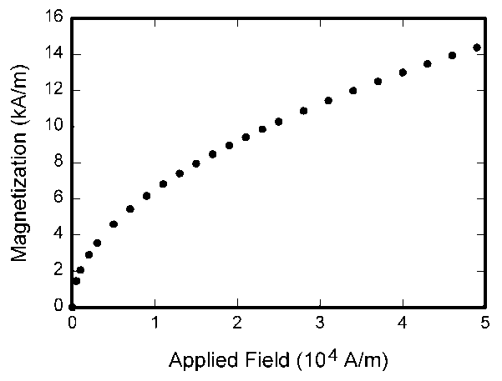
Fig. 1. Magnetization as a function of applied field.

Table

Use 9 points Times New Roman for the content of the table. Caption should appear center above each table in 8 points Times New Roman. The gap between the caption and table is 3pt line spacing.

TABLE 1: Explanation of the Main KSA Descriptor Sections
Section | Explanation
Summary | Provides an overall summary of the scope and performance outcomes of the KSA descriptor, including pathway, document ID, version & date and an overview of the recommended training & assessment delivery mechanisms.
Knowledge (K) | Provides a set of Knowledge elements for the competency area. This is what one should “know.”
Skills (S) | Provides a set of Skills elements for the competency area. This is what one should be “able to do.”
Assessment Methods | Provides a legend to explain the different possible assessment methods for the K & S elements
Attitudes (A) | Provides a set of Attitudes elements for the competency area. This is what traits one should exhibit. Unlike the K & S elements, it is not expected that an assessment method should explicitly measure these, but rather that a training program should blend them into the learning fabric. This must be evaluated when the training program is submitted for evaluation.

DISCUSSION

This section is on the explanation of the research results and outcome. Explain also the assumptions made and the research hypothesis.

CONCLUSION

This section is about the discovery and lesson learned from the research. It should also state what remains to be learned and the propose directions for future research on the problem. Evaluate the limitations of what was done in the research and the benefits, advantages, applications, etc. of the research.
This section should have the recommendations based on the outcome and on future undertaking of the similar problems.

ACKNOWLEDGEMENT

A statement on conflict of interest must be included in the manuscript if authors receive any support that might be construed to influence the results or interpretation of their manuscript. All sources of financial support for the project should be disclosed.

REFERENCES

Use the IEEE reference format. It should be relevant and mostly within 5 years from the research start date.

Basic format for journals (when available online):

- J. S. Turner, “New directions in communications,” IEEE J. Sel. Areas Commun., vol. 13, no. 1, pp. 11-23, Jan. 1995.
- W. P. Risk, G. S. Kino, and H. J. Shaw, “Fiber-optic frequency shifter using a surface acoustic wave incident at an oblique angle,” Opt. Lett., vol. 11, no. 2, pp. 115–117, Feb. 1986.

Basic format for papers presented at conferences (when available online):

- PROCESS Corporation, Boston, MA, USA. Intranets: Internet technologies deployed behind the firewall for corporate productivity. Presented at INET96 Annual Meeting. [Online]. Available: http://home.process.com/Intranets/wp2.htp

Basic format for books:

- G. O. Young, “Synthetic structure of industrial plastics,” in Plastics, 2nd ed., vol. 3, J. Peters, Ed. New York, NY, USA: McGraw-Hill, 1964, pp. 15–64.
- W.-K. Chen, Linear Networks and Systems. Belmont, CA, USA: Wadsworth, 1993, pp. 123–135.

Basic format for conference proceedings (published):

- D. B. Payne and J. R. Stern, “Wavelength-switched pas- sively coupled single-mode optical network,” in Proc. IOOC-ECOC, Boston, MA, USA, 1985,
pp. 585–590.

Basic format for periodicals:

- J. U. Duncombe, “Infrared navigation—Part I: An assessment of feasibility,” IEEE Trans. Electron Devices, vol. ED-11, no. 1, pp. 34–39, Jan. 1959, 10.1109/TED.2016.2628402.

Basic format for reports:

- E. E. Reber, R. L. Michell, and C. J. Carter, “Oxygen absorption in the earth’s atmosphere,” Aerospace Corp., Los Angeles, CA, USA, Tech. Rep. TR-0200 (4230-46)-3, Nov. 1988.

